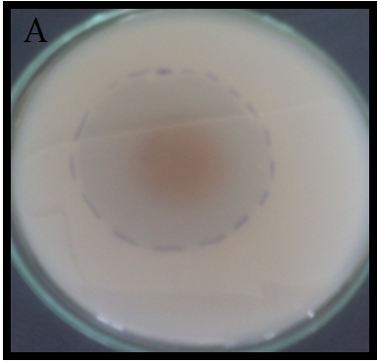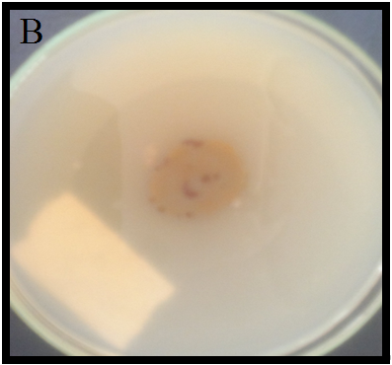

**Fig. S1.** Antimicrobial effect of F9 strain against MRSA (A) and VRE (B).

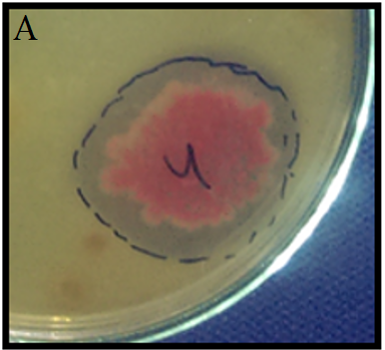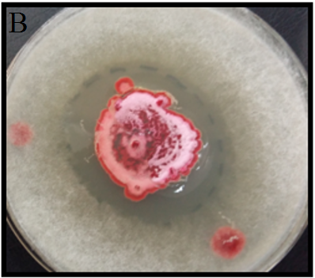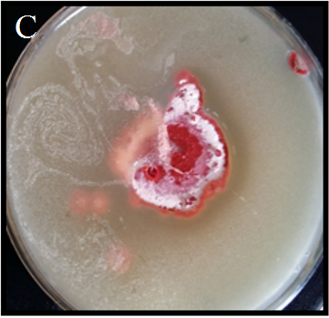

**Fig. S2.** Antimicrobial effect of F4 strain against MRSA (A), Rhizopus (B), Candida (C).

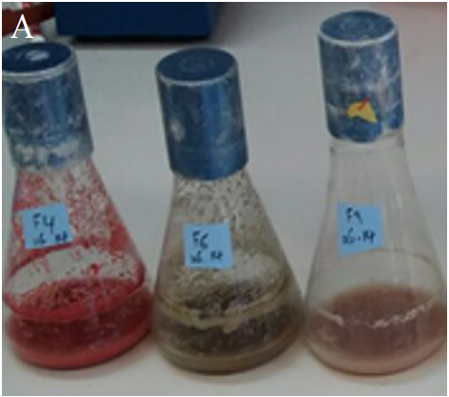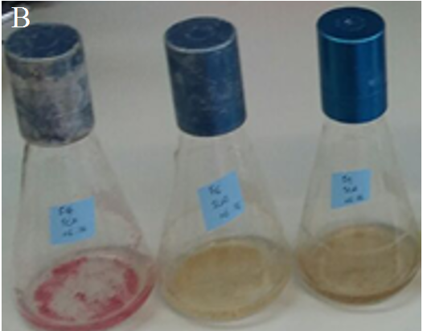

**Fig. S3.** Primary evaluation of antibiotic production by the strains F4 (at the left) and F9 strain (at the right) in two different media SM (A) and SC (B).

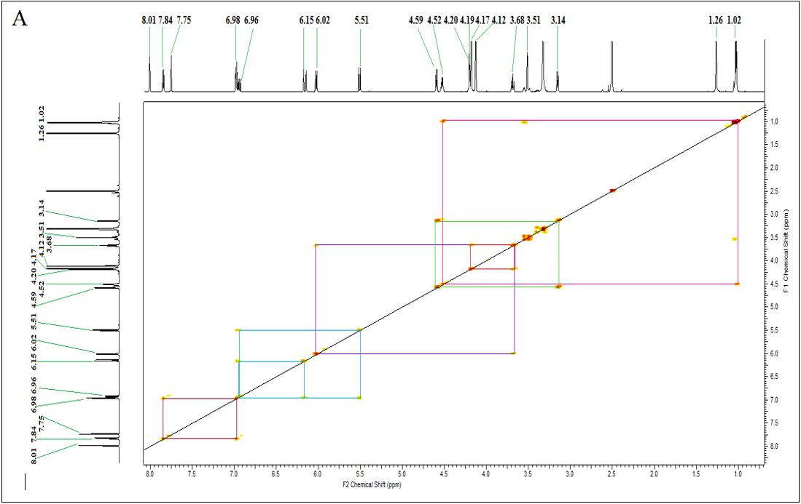

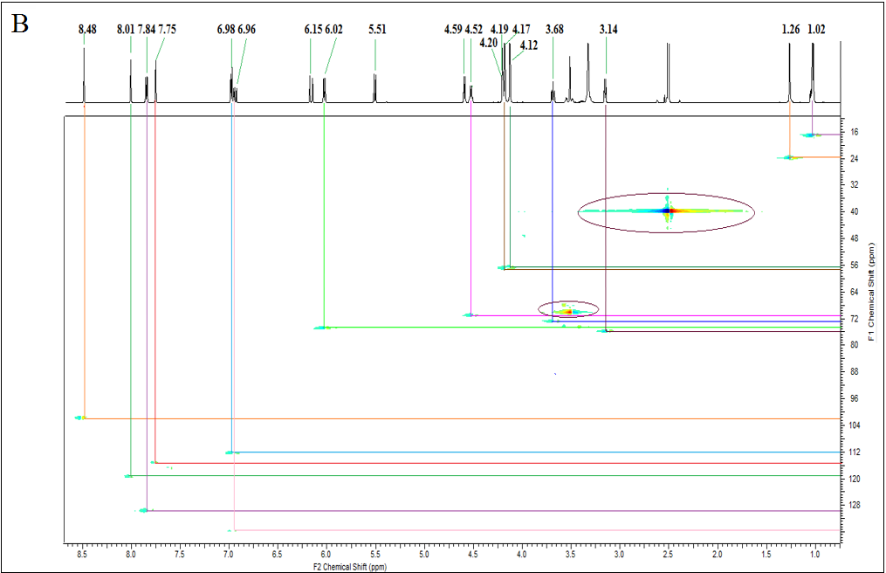

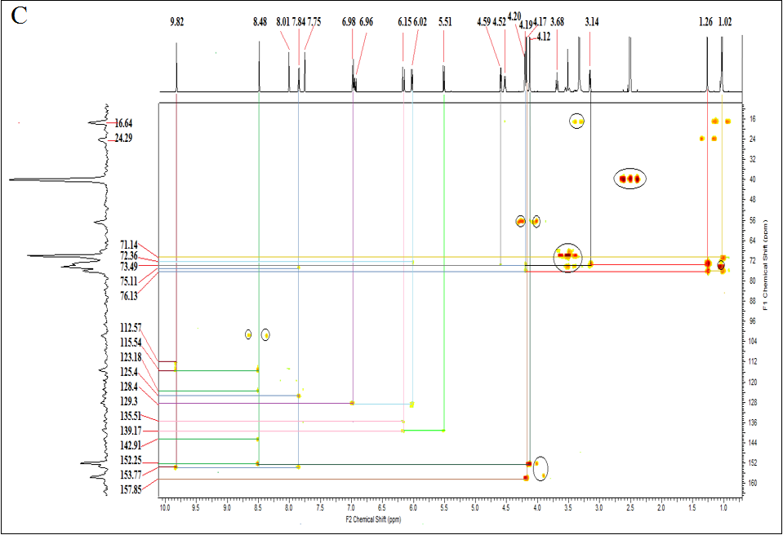

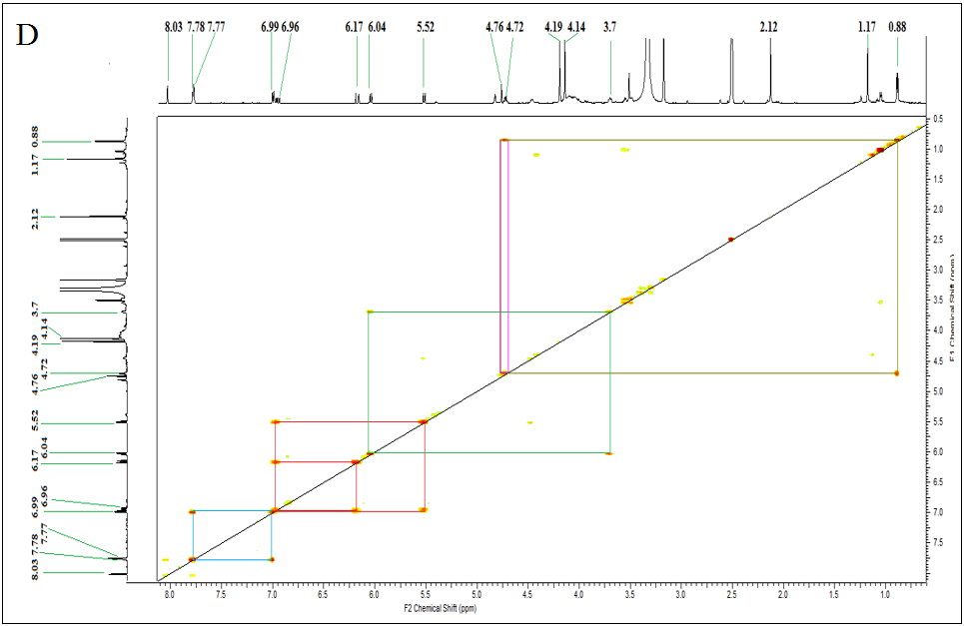

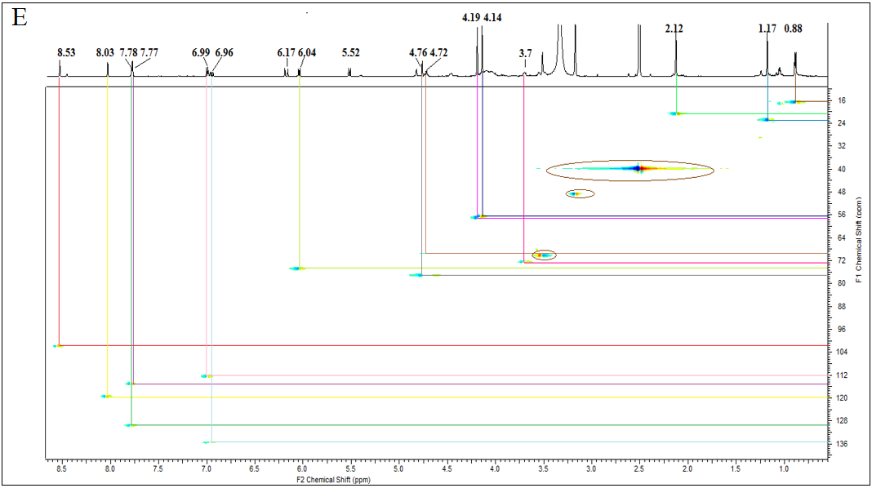

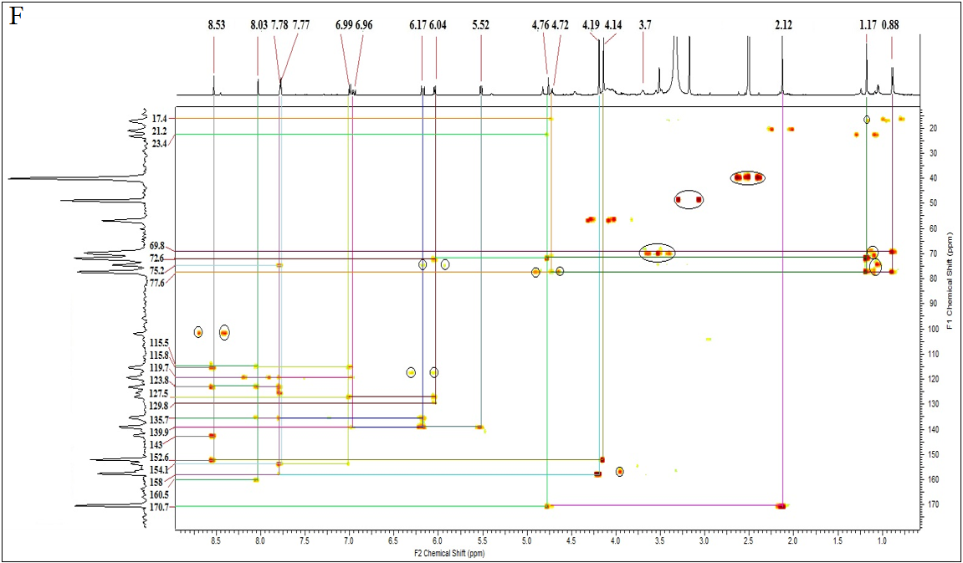

**Fig. S4.** Correlations found in the COSY, HSQC, and HMBC spectra of compounds 2 (A-C) and 4 (D-F).